#### A



***PROJECT REPORT***

*On*

**Ecommerce Store using Commercetools**

*Submitted in partial fulfilment of the requirements for the degree of*

#### BACHELOR OF TECHNOLOGY

2024

#### A

###### PROJECT REPORT

*On*

##### Ecommerce Store using commercetools

*Submitted in partial fulfilment of the requirements for the degree of*

#### BACHELOR OF TECHNOLOGY



**2024**

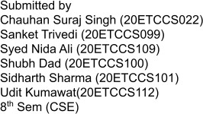





Department of Computer Science and Engineering Techno India NJR Institute of Technology, Udaipur-313001

# Certificate

This is to certify that project work titled **Ecommerce Store Using Commercetools** by **Chauhan Suraj Singh** was successfully carried out in the Department of Computer Science and Engineering, TINJRIT and the report is approved for submission in the partial fulfilment of the requirements for award of degree of Bachelor of Technology in Computer Science and Engineering.

Mr. Aaditya Maheshwari Dr. Rimpy Bishnoi

Assistant Professor Head of Department

Dept. of CSE TINJRIT, Udaipur Dept. of CSE TINJRIT, Udaipur

Date Date



Department of Computer Science and Engineering Techno India NJR Institute of Technology, Udaipur-313001

# Certificate

This is to certify that project work titled **Ecommerce Store Using Commercetools** by **Sanket Trivedi** was successfully carried out in the Department of Computer Science and Engineering, TINJRIT and the report is approved for submission in the partial fulfilment of the requirements for award of degree of Bachelor of Technology in Computer Science and Engineering.

Mr. Aaditya Maheshwari Dr. Rimpy Bishnoi

Assistant Professor Head of Department

Dept. of CSE TINJRIT, Udaipur Dept. of CSE TINJRIT, Udaipur

Date Date



Department of Computer Science and Engineering Techno India NJR Institute of Technology, Udaipur-313001

# Certificate

This is to certify that project work titled **Ecommerce Store Using Commercetools** by **Syed Nida Ali** was successfully carried out in the Department of Computer Science and Engineering, TINJRIT and the report is approved for submission in the partial fulfilment of the requirements for award of degree of Bachelor of Technology in Computer Science and Engineering.

Mr. Aaditya Maheshwari Dr. Rimpy Bishnoi

Assistant Professor Head of Department

Dept. of CSE TINJRIT, Udaipur Dept. of CSE TINJRIT, Udaipur

Date Date



Department of Computer Science and Engineering Techno India NJR Institute of Technology, Udaipur-313001

# Certificate

This is to certify that project work titled **Ecommerce Store Using Commercetools** by **Shubh Dad** was successfully carried out in the Department of Computer Science and Engineering, TINJRIT and the report is approved for submission in the partial fulfilment of the requirements for award of degree of Bachelor of Technology in Computer Science and Engineering.

Mr. Aaditya Maheshwari Dr. Rimpy Bishnoi

Assistant Professor Head of Department

Dept. of CSE TINJRIT, Udaipur Dept. of CSE TINJRIT, Udaipur

Date Date



Department of Computer Science and Engineering Techno India NJR Institute of Technology, Udaipur-313001

# Certificate

This is to certify that project work titled **Ecommerce Store Using Commercetools** by **Siddharth Sharma** was successfully carried out in the Department of Computer Science and Engineering, TINJRIT and the report is approved for submission in the partial fulfilment of the requirements for award of degree of Bachelor of Technology in Computer Science and Engineering.

Mr. Aaditya Maheshwari Dr. Rimpy Bishnoi

Assistant Professor Head of Department

Dept. of CSE TINJRIT, Udaipur Dept. of CSE TINJRIT, Udaipur

Date. Date



Department of Computer Science and Engineering Techno India NJR Institute of Technology, Udaipur-313001

# Certificate

This is to certify that project work titled **Ecommerce Store Using Commercetools** by **Udit Kumawat** was successfully carried out in the Department of Computer Science and Engineering, TINJRIT and the report is approved for submission in the partial fulfilment of the requirements for award of degree of Bachelor of Technology in Computer Science and Engineering.

Mr. Aaditya Maheshwari Dr. Rimpy Bishnoi

Assistant Professor Head of Department

Dept. of CSE TINJRIT, Udaipur Dept. of CSE TINJRIT, Udaipur

Date Date

# Examiner Certificate

This is to certify that the following students **Chauhan Suraj Singh** of final year B.Tech. (Computer Science and Engineering), was examined for the project work titled

###### Ecommerce Store Using Commercetools

during the academic year 2023 – 2024 at Techno India NJR Institute of Technology, Udaipur.

##### Remarks:

**Date:**

Signature Signature

(**Internal Examiner**) (**External Examiner**) Name: - Name: -

Designation: - Designation: -

Department: - Department: -

Organization: - Organization: -

# Examiner Certificate

This is to certify that the following students **Sanket Trivedi** of final year B.Tech. (Computer Science and Engineering), was examined for the project work titled

###### Ecommerce Store Using Commercetools

during the academic year 2023 – 2024 at Techno India NJR Institute of Technology, Udaipur.

##### Remarks:

**Date:**

Signature Signature

(**Internal Examiner**) (**External Examiner**) Name: - Name: -

Designation: - Designation: -

Department: - Department: -

Organization: - Organization: -

# Examiner Certificate

This is to certify that the following students **Syed Nida Ali** of final year B.Tech. (Computer Science and Engineering), was examined for the project work titled

###### Ecommerce Store Using Commercetools

during the academic year 2023 – 2024 at Techno India NJR Institute of Technology, Udaipur.

##### Remarks:

**Date:**

Signature Signature

(**Internal Examiner**) (**External Examiner**) Name: - Name: -

Designation: - Designation: -

Department: - Department: -

Organization: - Organization: -

# Examiner Certificate

This is to certify that the following students **Shubh Dad** of final year B.Tech. (Computer Science and Engineering), was examined for the project work titled

###### Ecommerce Store Using Commercetools

during the academic year 2023 – 2024 at Techno India NJR Institute of Technology, Udaipur.

##### Remarks:

**Date:**

Signature Signature

(**Internal Examiner**) (**External Examiner**) Name: - Name: -

Designation: - Designation: -

Department: - Department: -

Organization: - Organization: -

# Examiner Certificate

This is to certify that the following students **Siddharth Sharma** of final year B.Tech. (Computer Science and Engineering), was examined for the project work titled

###### Ecommerce Store Using Commercetools

during the academic year 2023 – 2024 at Techno India NJR Institute of Technology, Udaipur.

##### Remarks:

**Date:**

Signature Signature

(**Internal Examiner**) (**External Examiner**) Name: - Name: -

Designation: - Designation: -

Department: - Department: -

Organization: - Organization: -

# Examiner Certificate

This is to certify that the following students **Udit Kumawat** of final year B.Tech. (Computer Science and Engineering), was examined for the project work titled

###### Ecommerce Store Using Commercetools

during the academic year 2023 – 2024 at Techno India NJR Institute of Technology, Udaipur.

##### Remarks:

**Date:**

Signature Signature

(**Internal Examiner**) (**External Examiner**) Name: - Name: -

Designation: - Designation: -

Department: - Department: -

Organization: - Organization: -

## ACKNOWLEDGMENT

We take this opportunity to record our sincere thanks to all who helped us to successfully complete this work. Firstly, we are grateful to our **supervisor Mr. Aaditya Maheshwari** for his invaluable guidance and constant encouragement, support and most importantly for giving us the opportunity to carry out this work.

We would like to express our deepest sense of gratitude and humble regards to our

**Head of Department Dr. Rimpy Bishnoi** for giving invariable encouragement in our endeavours and providing necessary facilities for the same. Also a sincere thanks to all faculty members of CSE, TINJRIT for their help in the project directly or indirectly.

Finally, we would like to thank my friends for their support and discussions that have proved very valuable for us. We are indebted to our parents for providing constant support, love and encouragement. We thank them for the sacrifices they made so that we could grow up in a learning environment. They have always stood by us in everything we have done, providing constant support, encouragement and love.

##### Chauhan Suraj Singh (20ETCCS022) Sanket Trivedi (20ETCCS099)

**Syed Nida Ali (20ETCCS109) Shubh Dad(20ETCCS100) Siddharth Sharma (20ETCCS101) Udit Kumawat(20ETCCS112)**

DEPARTMENT OF COMPUTER SCIENCE AND ENGINEERING TECHNO INDIA NJR INSTITUTE OF TECHNOLOGY, UDAIPUR-313001

**CONTENTS**

|  |  |
| --- | --- |
| Certificate 1 | ii - vii |
| Certificate 2 | viii - xiii |
| Acknowledgements | xiv |
| List of Tables | xv |
| List of Figures | xvi |
| Chapter 1: Introduction   * 1. Title of Project   2. Problem Statement 1.3Objective of the Project   3. Scope of the Project   4. Methodology   5. Software/ Technology Used | 1 - 5 |
| Chapter 2: Commercetools CMS Backend Service   * 1. Introduction   2. MACH Architecture   3. Rest API | 6 - 14 |
| Chapter 3: B2C Marketplace   * 1. Storefront   2. Backend Connection with API’s | 15 - 21 |
| Conclusion | 22 |
| Future Scope | 23 - 24 |
| Bibliography | 25 |

# LIST OF FIGURES

|  |  |
| --- | --- |
| FIG.1.1 Commercetools Architecture | 4 |
| FIG.1.2 API in Composable Commercetools | 5 |
| FIG.2.1.1 Commercetools Dashboard | 7 |
| FIG.2.1.2 Commercetools Product Dashboard | 8 |
| FIG.2.1.3 Commercetools Customer Dashboard | 8 |
| FIG.2.1.4 Commercetools Add Customer Dashboard | 9 |
| Fig 2.1.5: Commercetools Categories Dashboard | 9 |
| FIG.2.2.1 Commercetools Mach Architecture | 11 |
| FIG.2.3.1 Postman HTTP API (Add Item To Cart) | 13 |
| FIG.2.3.2 Postman HTTP API (Obtain Access Token) | 14 |
| FIG.2.3.3 Postman HTTP API (Get Products) | 14 |
| Fig 3.1.1 Storefront Home Page | 16 |
| Fig 3.1.2 Storefront Product Listing Page(PLP) | 16 |
| Fig 3.1.3 Storefront Product Description Page(PDP) | 17 |
| Fig 3.1.4 Storefront Categories Listing Page | 17 |
| Fig 3.1.5 Storefront Cart Listing Page | 18 |
| Fig 3.1.6 Storefront User Registration Page | 18 |
| Fig 3.1.7 Storefront User Description Page(UDP) | 19 |
| FIG.3.2.1 Backend API Connection Code 1 | 20 |
| FIG.3.2.2 Backend API Connection Code 2 | 21 |
| FIG.3.2.3 Backend API Connection Code 3 | 21 |

## CHAPTER 1: INTRODUCTION

##### Title of the project:

Ecommerce Store Using Commercetools

##### Problem Statement:

In the rapidly evolving landscape of online retail, businesses face the challenges of enhancing their e-commerce platform to meet the growing expectations of consumers. The current system lacks optimal issues. As a result, there is a pressing need to revamp the existing e-commerce infrastructure to deliver a more intuitive, secure and scalable platform that not only keeps pace with technological advancements but also provides a delightful and personalized shopping experience for customers. This project aims to address these challenges and elevate e-commerce capabilities to drive customer satisfaction, increase sales and position our business for sustained growth in the digital marketplace.

Cnetric Global aims to create a robust and scalable e-commerce platform to effectively handle and manage Product Information Management (PIM) for our business. To achieve this, we plan to leverage modern tools and technologies, such as Commercetools, Shopify and Elastic Path, to ensure a seamless and efficient online shopping experience for our customers.

##### Objective of the project:

* **Commercetools: -** Commerce tools is a headless platform that empowers businesses to create engaging shopping experiences across all digital touchpoints. It offers limitless Commercetools possibilities, making it a beacon of innovation in the eCommerce landscape. Commercetools provides the leading composable commerce platform. It powers commerce infrastructure-influence competitive advantages, long-term business value and agility for the enterprises across every industry while reducing their total costs.

##### Scope of the project:

* **Commercetools: -**
  1. **Online Store Setup: -** Creating a digital platform for businesses to showcase and sell their products or services.
  2. **Product Management: -** Efficiently managing and organizing the product catalogue, including adding new items, updating details and handling inventory.
  3. **User-Friendly Shopping Experience: -** Ensuring a seamless and user-friendly experience for customers as they browse, search and make purchases on the online store.
  4. **Customization and Flexibility: -** Tailoring the e-commerce solution to meet specific business needs, allowing for flexibility and adaptability.
  5. **Integration with Other Systems: -** Connecting the e-commerce platform with other business systems, like payment gateways, shipping services and customer relationship management (CRM) tools.
  6. **Order Management: -** Streamlining the process of order placement, tracking and fulfilment to enhance efficiency.
  7. **Security and Compliance: -** Implementing robust security measures to protect customer data and ensuring compliance with industry regulations.
  8. **Scalability: -** Designing the e-commerce solution to grow with the business, accommodating increased traffic, product offerings and user interactions.
  9. **Analytics and Reporting: -** Providing tools for businesses to analyse data, track performance and make informed decisions to improve sales and customer satisfaction.
  10. **API-Based Approach: -** Leveraging Commercetools API-based approach for a more modular and customizable solution allowing businesses to integrate new features and technologies easily.

##### Methodology:

* + 1. **Business Plan and Research: -** Define your business goals and objectives. Research your target market and competition. Identify your unique selling propositions.
    2. **Product Selection and Sourcing: -** Decide what products or services you'll offer. Source or create your products.
    3. **Platform Selection: -** Choose an e-commerce platform such as Shopify, WooCommerce, Magento, or others based on your specific needs.
    4. **Website Development: -** Set up your e-commerce website using the chosen platform. Customize the design and layout to reflect your brand.
    5. **Product Listing: -** Add product descriptions, images, and pricing to your online store. Organize products into categories for easy navigation.
    6. **Payment Processing: -** Set up payment gateways to securely process customer transactions.
    7. **Shipping and Logistics: -** Define shipping options and rates. Integrate with shipping carriers for order fulfilment.
    8. **Legal and Compliance: -** Ensure you comply with e-commerce regulations and data privacy laws. Create refund and return policies.
    9. **Security: -** Implement security measures to protect customer data and payment information.
    10. **Marketing and SEO: -** Develop a marketing strategy to promote your online store. Optimize your website for search engines (SEO).
    11. **Launch and Testing: -** Test the website thoroughly for functionality and usability. Conduct a soft launch to a limited audience for initial feedback.
    12. **Customer Support: -** Set up customer support channels (email, chat, phone) to assist customers.

##### Software/ Technology used:

* Postman for API Testing
* React JS 18.2.0
* JavaScript ES14
* GitHub
* Commercetools:

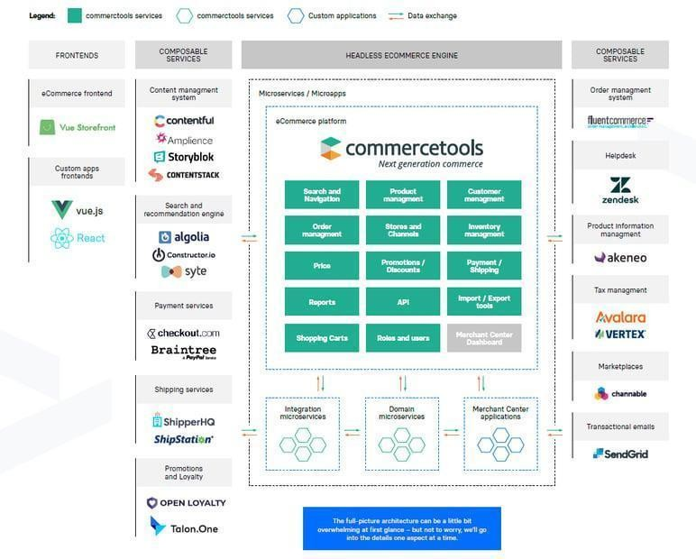

**Fig.1.1 Commercetools Architecture**

**REST API:**

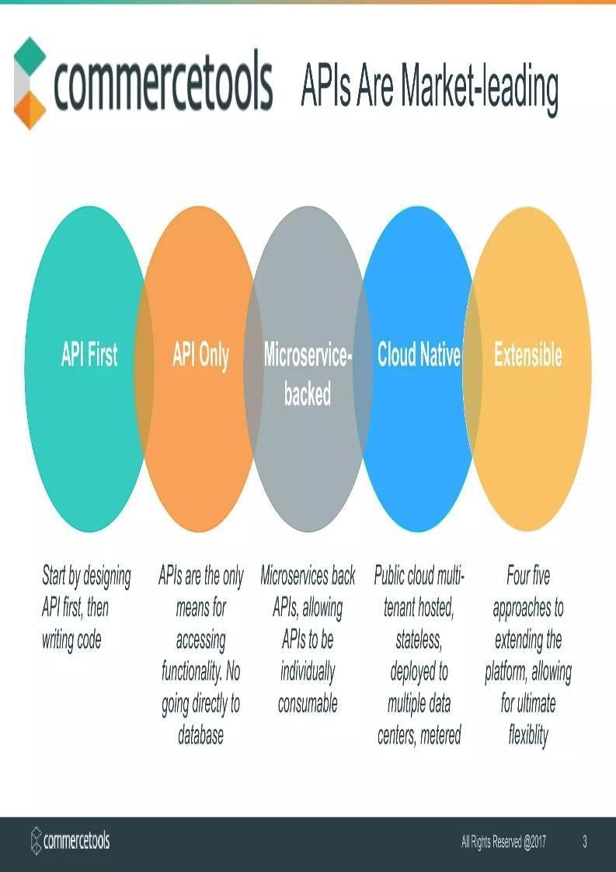

**Fig.1.2 API IN COMPOSABLE COMMERCE COMMERCETOOLS**

### Chapter 2: Commercetools CMS Backend Service

##### Introduction: -

A CMS, or Content Management System, is a software application or set of related programs that are used to create and manage digital content. It provides a centralized interface for users to easily author, edit, organize, and publish content on websites or other digital platforms without requiring advanced technical knowledge. Here's an overview of the key components and functionalities of a CMS:

* + - **Content Creation:** A CMS allows users to create and input various types of content, including text, images, videos, documents, and more. Content can be authored using a built-in editor or imported from external sources.
    - **Content Editing:** Users can edit existing content directly within the CMS interface. The editing tools typically include formatting options, media embedding, hyperlinking, and other features to enhance the presentation and usability of the content.
    - **Content Organization:** A CMS provides tools for organizing and structuring content into categories, tags, or hierarchical structures such as folders or taxonomies. This helps users manage large volumes of content and improve navigation for website visitors.
    - **Content Management:** CMS platforms offer features for managing content throughout its lifecycle, including version control, workflow management, and permissions settings. These capabilities enable collaboration among multiple users and ensure content consistency and quality.
    - **User Management:** CMS platforms include user management features for controlling access to the system and defining user roles and permissions. Administrators can assign different levels of access to users based on their responsibilities and requirements.
    - **Design and Theming:** Many CMS platforms offer customizable templates or themes that define the visual appearance and layout of the website. Users can choose from pre-designed themes or create custom designs using built-in tools or integrations with design software.
    - **Extensions and Integrations:** CMS platforms often support extensions or plugins that extend the core functionality of the system. These extensions can add features such as e-commerce, SEO optimization, analytics, social media integration, and more, allowing users to tailor the CMS to their specific needs.
    - **SEO and Metadata Management:** CMS platforms include tools for optimizing content for search engines by allowing users to add meta tags, keywords, and other SEO elements to individual pages or posts. This helps improve the visibility and ranking of the website in search engine results.
    - **Analytics and Reporting:** Some CMS platforms offer built-in analytics and reporting tools that provide insights into website performance, user engagement, and content effectiveness. Users can track metrics such as page views, visitor demographics, conversion rates, and more to inform their content strategy and optimization efforts.

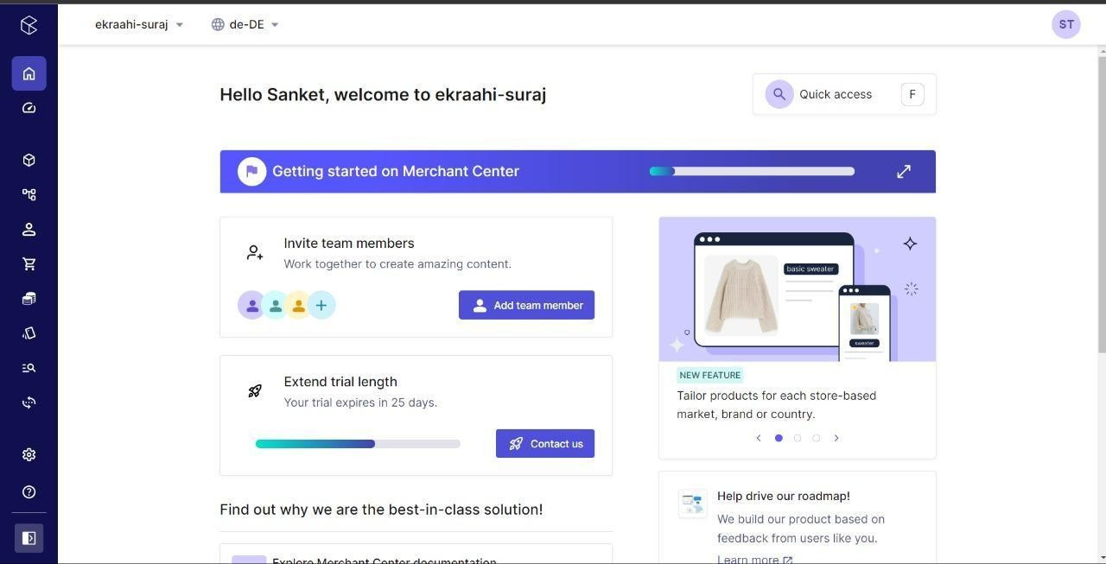

**Fig 2.1.1: Commercetools Dashboard**

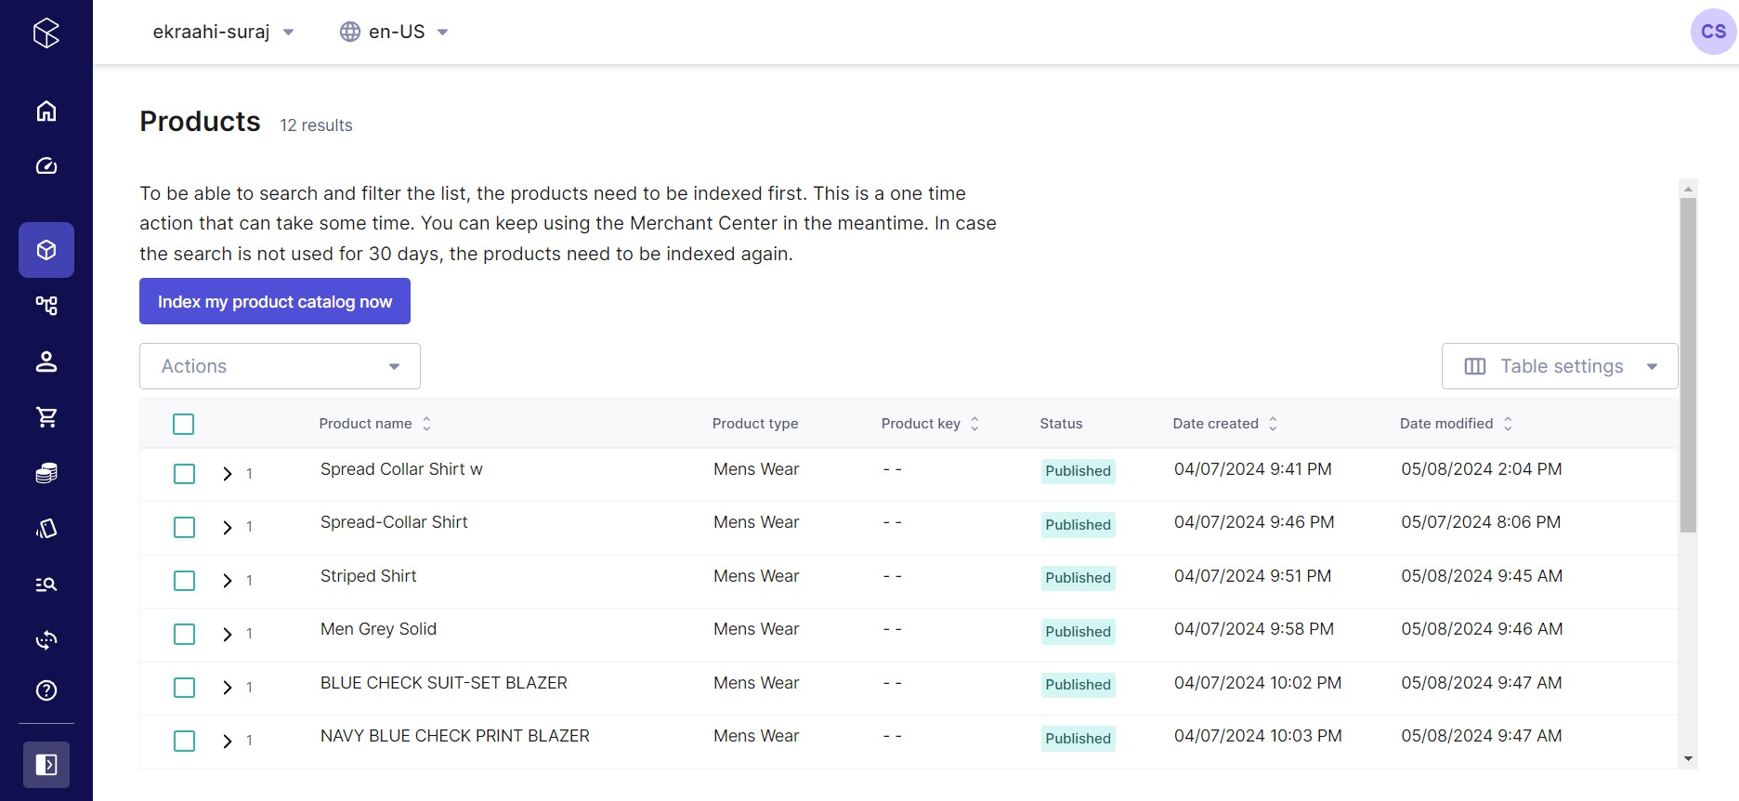

**Fig 2.1.2: Commercetools Product Dashboard**

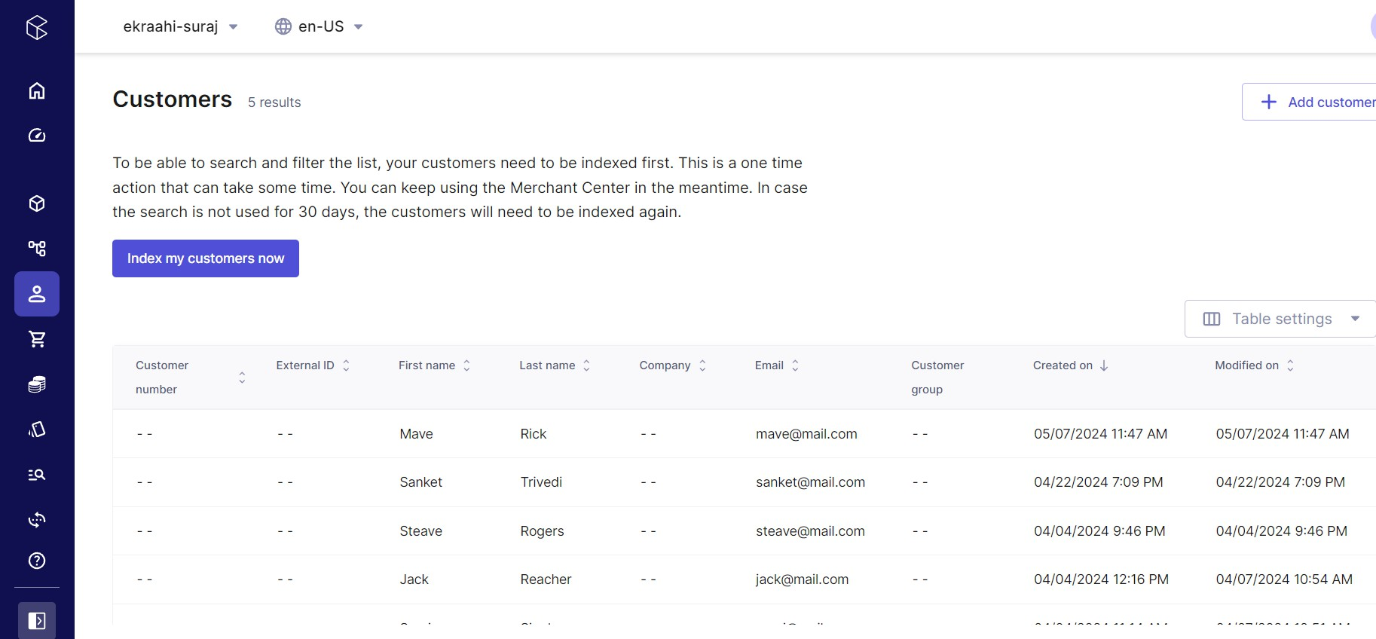

**Fig 2.1.3: Commercetools Customers Dashboard**

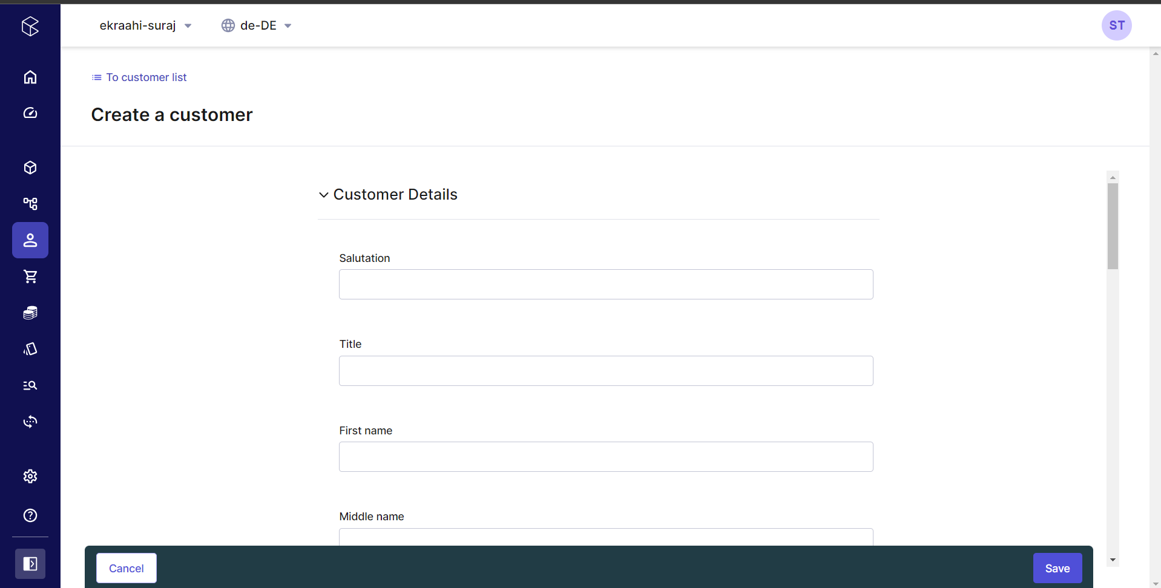

**Fig 2.1.4: Commercetools Add Customer Dashboard**

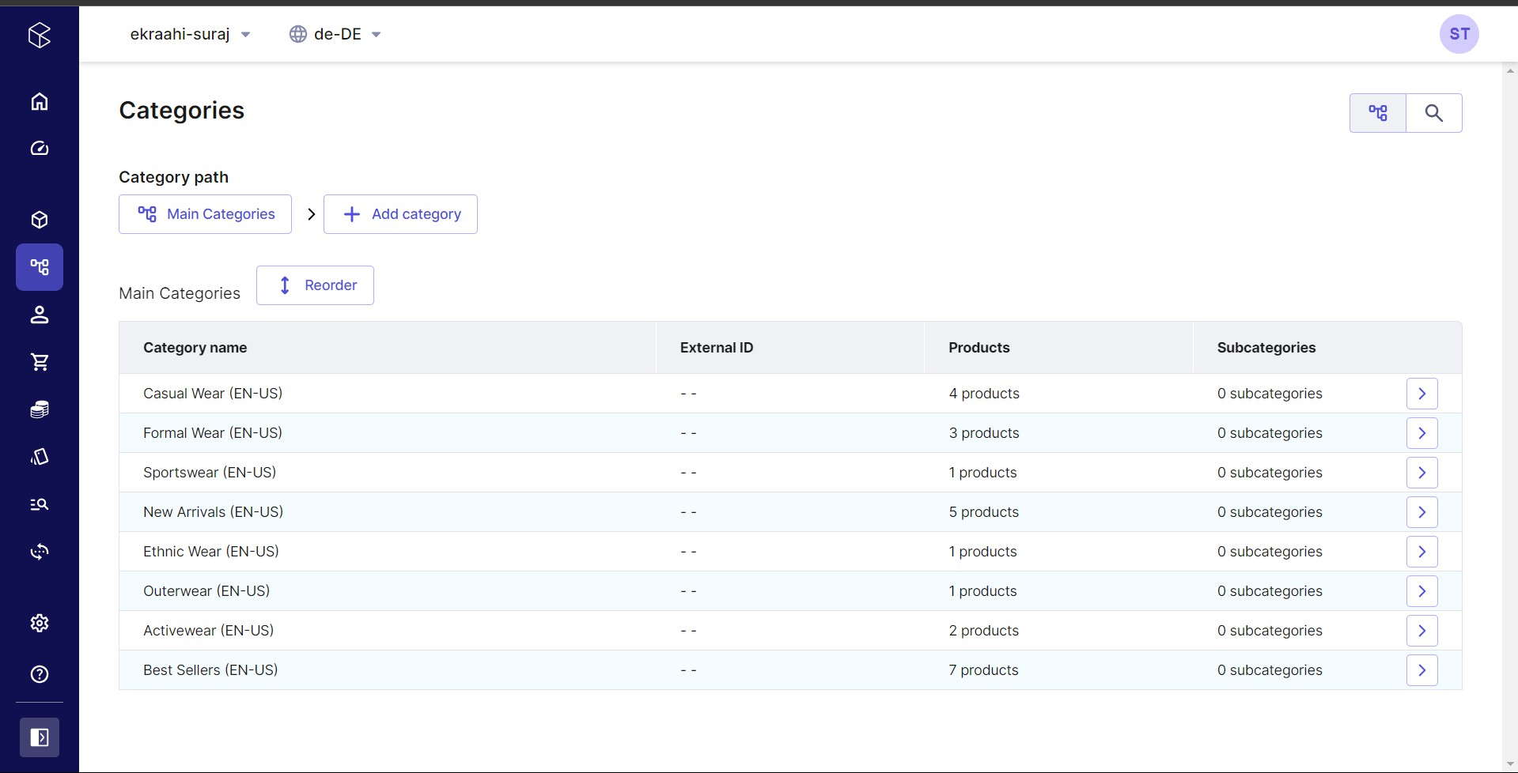

**Fig 2.1.5: Commercetools Categories Dashboard**

##### MACH Architecture:

MACH architecture is a set of technology principles behind new, best-of-breed technology platforms. The acronym stands for Microservices-based, API-first, Cloud-native, and Headless:

* + - Microservices: Individual pieces of business functionality that are independently developed, deployed and managed.
    - API-first: All functionality is exposed through an API, making it possible to tie together two or more applications or services.
    - Cloud-Native SaaS: Software-as-a-Service that leverages the full capabilities of the cloud, beyond storage and hosting, including elastic scaling of highly available resources. Functionality is updated automatically, eliminating the need for upgrade management.
    - Headless: The front-end user experience is completely decoupled from the back-end logic, allowing for complete design freedom in creating the user interface and for connecting to other channels and devices (i.e. existing applications, IoT, A/R, Vending Machines, sensors, etc.).

While it’s a relatively new term in the industry, MACH is quickly gaining popularity for how it helps businesses. MACH technologies support a composable enterprise meaning every component is pluggable, scalable, replaceable, and can be continuously improved. MACH architecture gives businesses the freedom to choose from the best tools on the market, and maintain a structure that makes it easy to add, replace, or remove those tools in the future.

Moving from monolithic or suite-based technology to MACH architecture gives you the freedom to choose from the best tools on the market today, and provides a structure that makes it easy to add, replace, or remove technologies in the future. Put simply, MACH architecture allows you to break the replatform cycle once and for all.

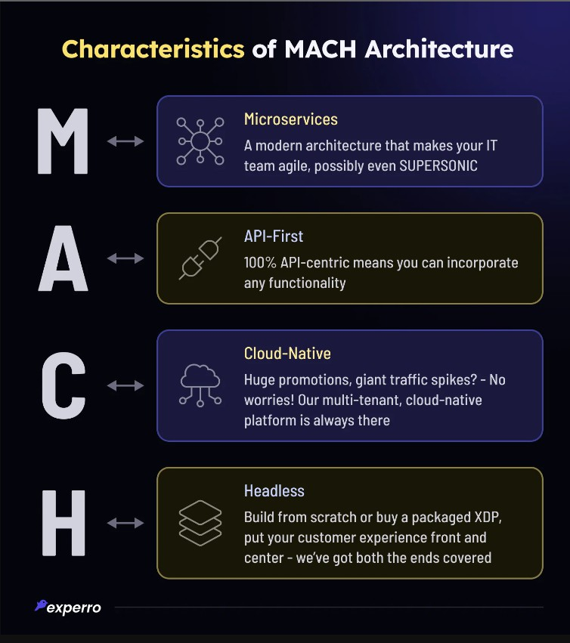

**Fig 2.2.1 Commercetools MACH Architecture**

#### REST API:

A RESTful API (Representational State Transfer API) is an architectural style for designing networked applications. It defines a set of constraints that should be followed while building web services to enable interoperability between systems. Here's an overview of the key principles and components of a RESTful API:

* + - **Resources:** In REST, everything is considered a resource, which is any piece of information that can be accessed via a URI (Uniform Resource Identifier). Resources are represented by URIs, and each resource should have a unique identifier.
    - **HTTP Methods (Verbs):** RESTful APIs use standard HTTP methods (also known as HTTP verbs) to perform actions on resources. The most common HTTP methods used in RESTful APIs are:
      * GET: Retrieve a representation of a resource.
      * POST: Create a new resource.
      * PUT: Update an existing resource (or create a new one if it doesn't exist).
      * DELETE: Remove a resource.
      * PATCH: Partially update a resource.
    - **Uniform Interface:** RESTful APIs have a uniform interface, which means that the interactions between clients and servers should follow standardized conventions. This simplifies communication and allows clients to understand how to interact with the API without prior knowledge of its implementation details.
    - **Statelessness:** RESTful APIs are stateless, meaning that each request from a client to the server must contain all the information necessary to process the request. The server does not maintain any client state between requests. This simplifies scalability and enhances reliability and performance.
    - **Representation:** Resources in a RESTful API are represented in a format such as JSON (JavaScript Object Notation) or XML (eXtensible Markup Language). Clients and servers communicate by exchanging representations of resources, which contain both data and metadata.
    - **Hypermedia as the Engine of Application State (HATEOAS) :** HATEOAS is a constraint in RESTful APIs that allows clients to navigate the API dynamically by following hyperlinks embedded in resource representations. This enables discoverability and decouples the client from specific endpoint URLs, making the API more flexible and resilient to changes.
    - **State Transfer :** RESTful APIs transfer the state of a resource between client and server through representations. Clients can retrieve, create, update, or delete resource representations using the appropriate HTTP methods.
    - **Security :** RESTful APIs should implement appropriate security measures, such as authentication and authorization mechanisms, to protect resources and ensure secure communication between clients and servers.

Overall, RESTful APIs provide a scalable, flexible, and standardized approach to building distributed systems, enabling interoperability and communication between different software components and services over the web.

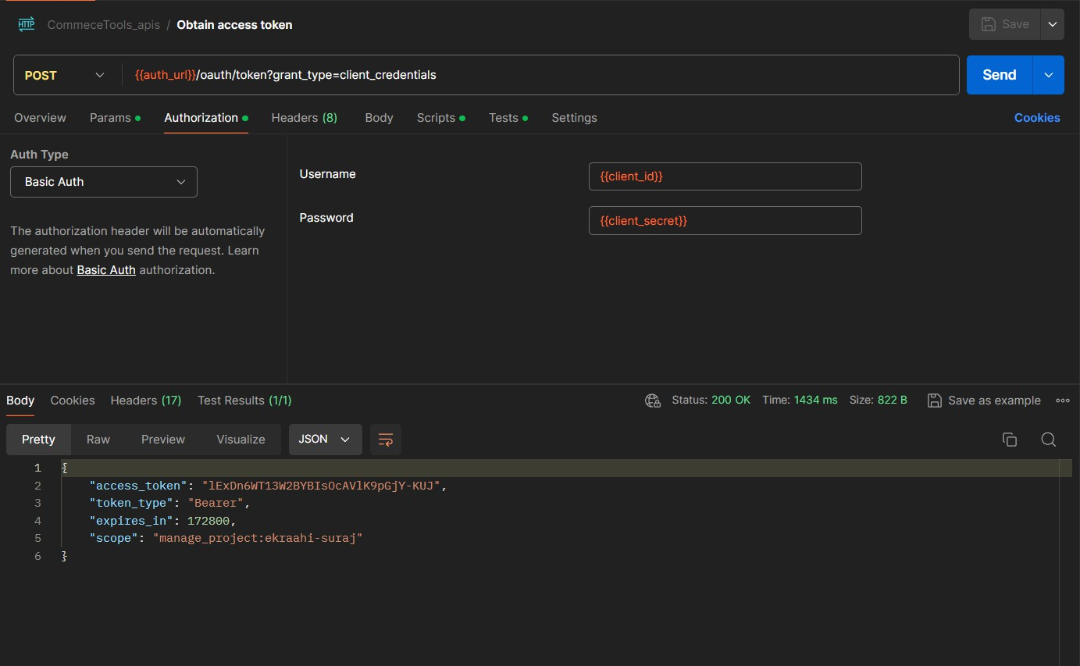

**Fig 2.3.1: Postman HTTP API (Add Item To Cart)**

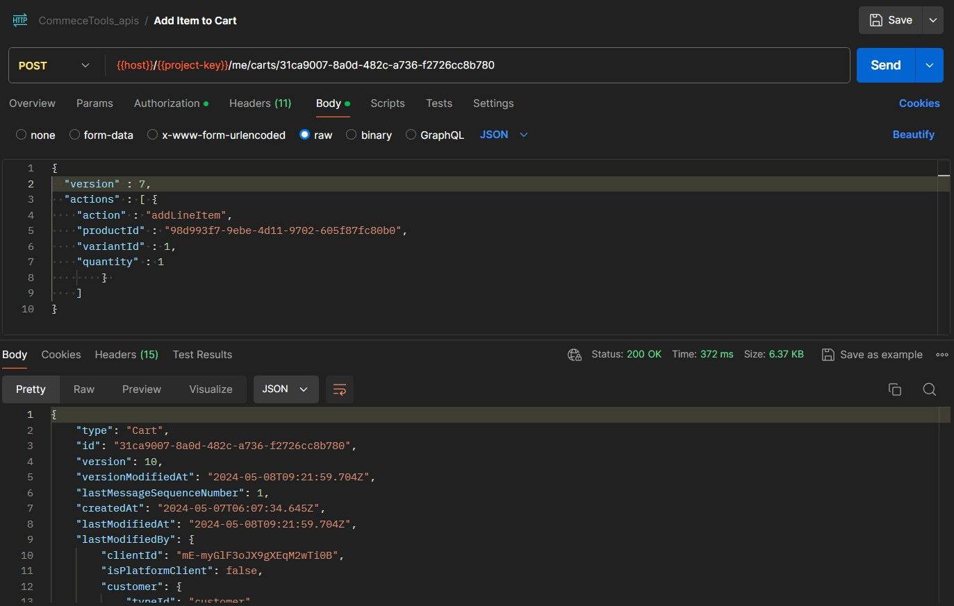

**Fig 2.3.2: Postman HTTP API (obtain access token)**

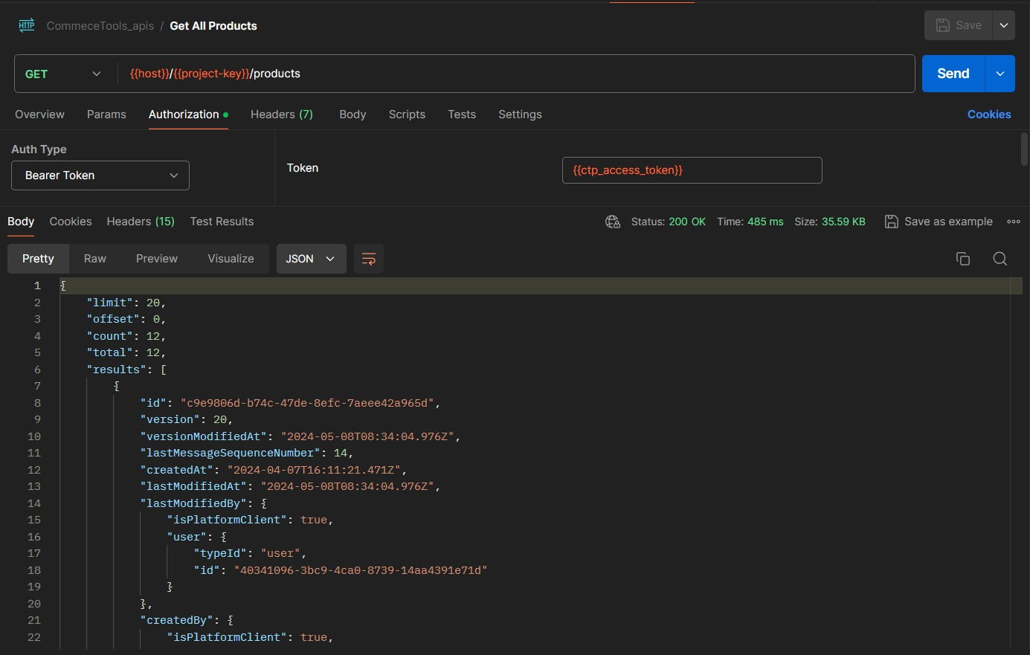

**Fig 2.3.3: Postman HTTP API (Get All Products)**

### CHAPTER 3: B2C MarketPlace

* 1. **Storefront: -**

Commercetools offers a flexible and scalable API-based commerce platform that enables businesses to create unique and customizable digital storefronts. These storefronts are tailored to the specific needs and branding of the business, providing a seamless and engaging shopping experience for customers.

A Commercetools storefront typically includes:

**Product Catalog:** A visually appealing display of products with detailed descriptions, images, and pricing information.

**Search and Navigation:** Tools to help customers easily find products they're looking for, such as search bars, filters, and category navigation.

**Shopping Cart:** A virtual shopping cart where customers can add products for purchase and review the items before checkout.

**Checkout Process:** A streamlined and secure checkout flow where customers enter shipping and payment details to complete their purchase.

**Account Management**: Options for customers to create accounts, manage their profiles, track orders, and view order history.

**Personalization**: Features that enable personalized product recommendations, promotions, and content based on customer preferences and behavior.

**Responsive Design:** Support for mobile devices and different screen sizes to ensure a consistent and user-friendly experience across devices.

**Integration Capabilities:** Seamless integration with third-party services such as payment gateways, shipping providers, and marketing tools to enhance functionality and optimize operations.



**Fig 3.1.1 : Storefront Home Page**



**Fig 3.1.2 : Storefront Product Listing Page(PLP)**



**Fig 3.1.3 : Storefront Product Description Page(PDP)**



**Fig 3.1.4 : Storefront Categories Listing Page**

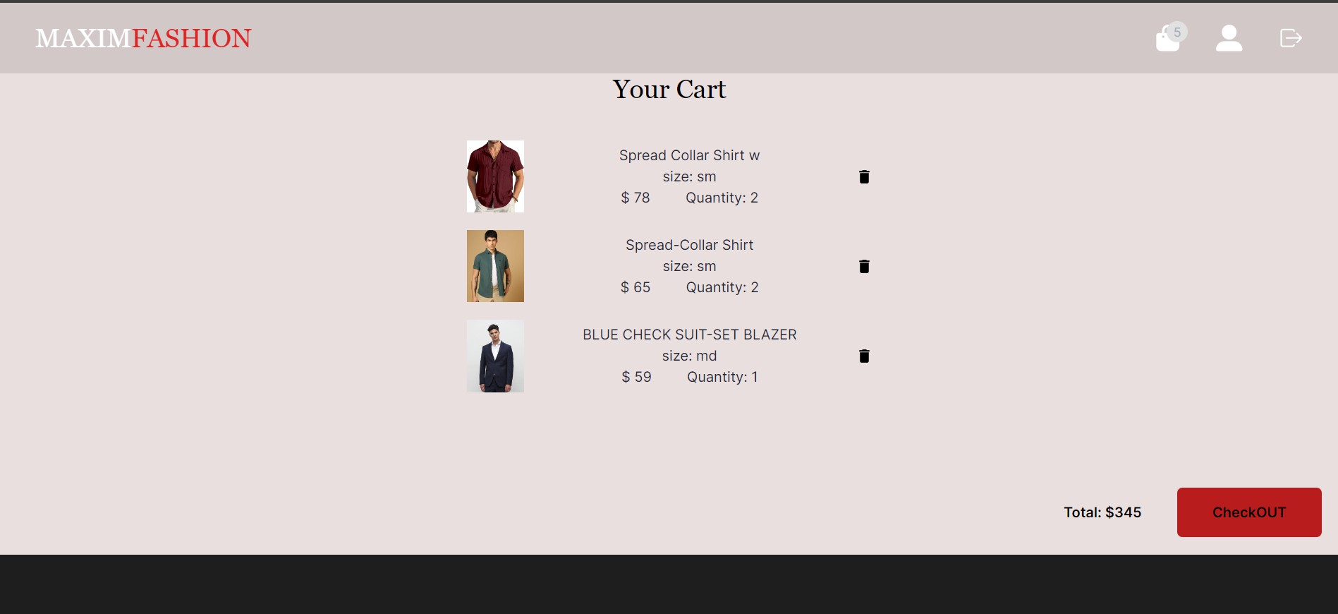

**Fig 3.1.5 : Storefront Cart Listing Page**

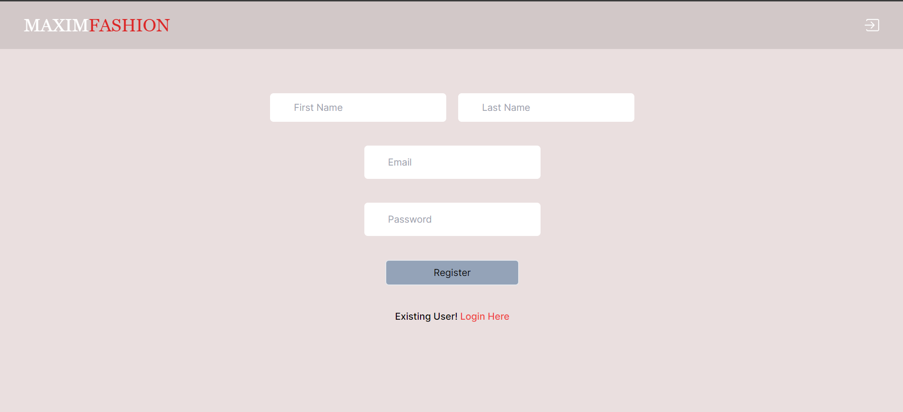

**Fig 3.1.6 : Storefront User Registration Page**



**Fig 3.1.7 : Storefront User Description Page(UDP)**

* 1. **Backend Connection with API:**

Commercetools offers a robust set of APIs (Application Programming Interfaces) that allow developers to connect and interact with the platform's backend services programmatically. These APIs enable businesses to build custom front-end experiences, integrate with third-party systems, and automate various e-commerce processes.

Here's how the backend connection with Commercetools' API typically works:

**Authentication:** Before accessing any resources or performing actions, developers need to authenticate themselves with the Commercetools platform. This is usually done using API keys or OAuth tokens to ensure secure communication.

**API Endpoints**: Commercetools provides a wide range of API endpoints that represent different resources and functionalities within the platform. These endpoints allow developers to perform actions such as managing product catalog, processing orders, handling customer data, and more.

**RESTful Architecture**: Commercetools follows a RESTful architecture for its APIs, which means that each resource is represented by a URL, and HTTP methods (GET, POST, PUT, DELETE, etc.) are used to perform operations on these resources. For example, to fetch a list of products, developers would send a GET request to the appropriate product endpoint.

**Data Modelling**: Commercetools uses a flexible and extensible data model called the "GraphQL Data Model" for structuring and managing e-commerce data. This model allows developers to define custom data types, attributes, and relationships to suit their specific business needs.

**API Clients and SDKs:** Commercetools provides official API clients and software development kits (SDKs) for popular programming languages such as JavaScript, Java, Python, and .NET. These clients abstract away the low-level details of HTTP communication and provide convenient methods for interacting with the API.

**Webhooks:** Commercetools supports webhooks, which are HTTP callbacks that are triggered by events that occur within the platform (e.g., order created, inventory updated). Developers can configure webhooks to receive real-time notifications about these events and take appropriate actions in external systems.

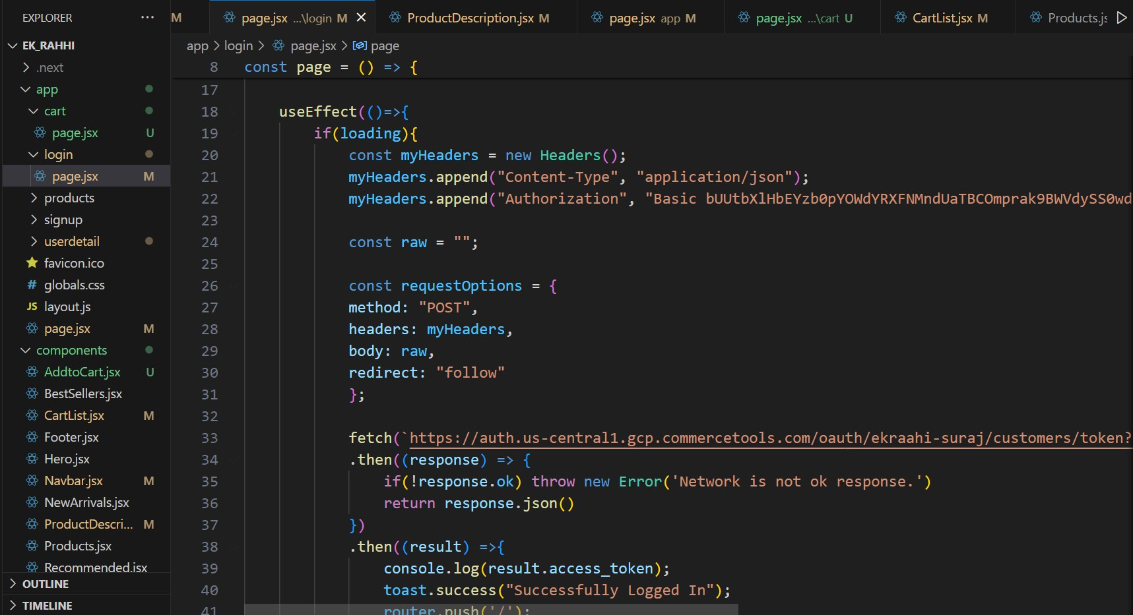

**Fig 3.2.1 : Backend API Connection 1**

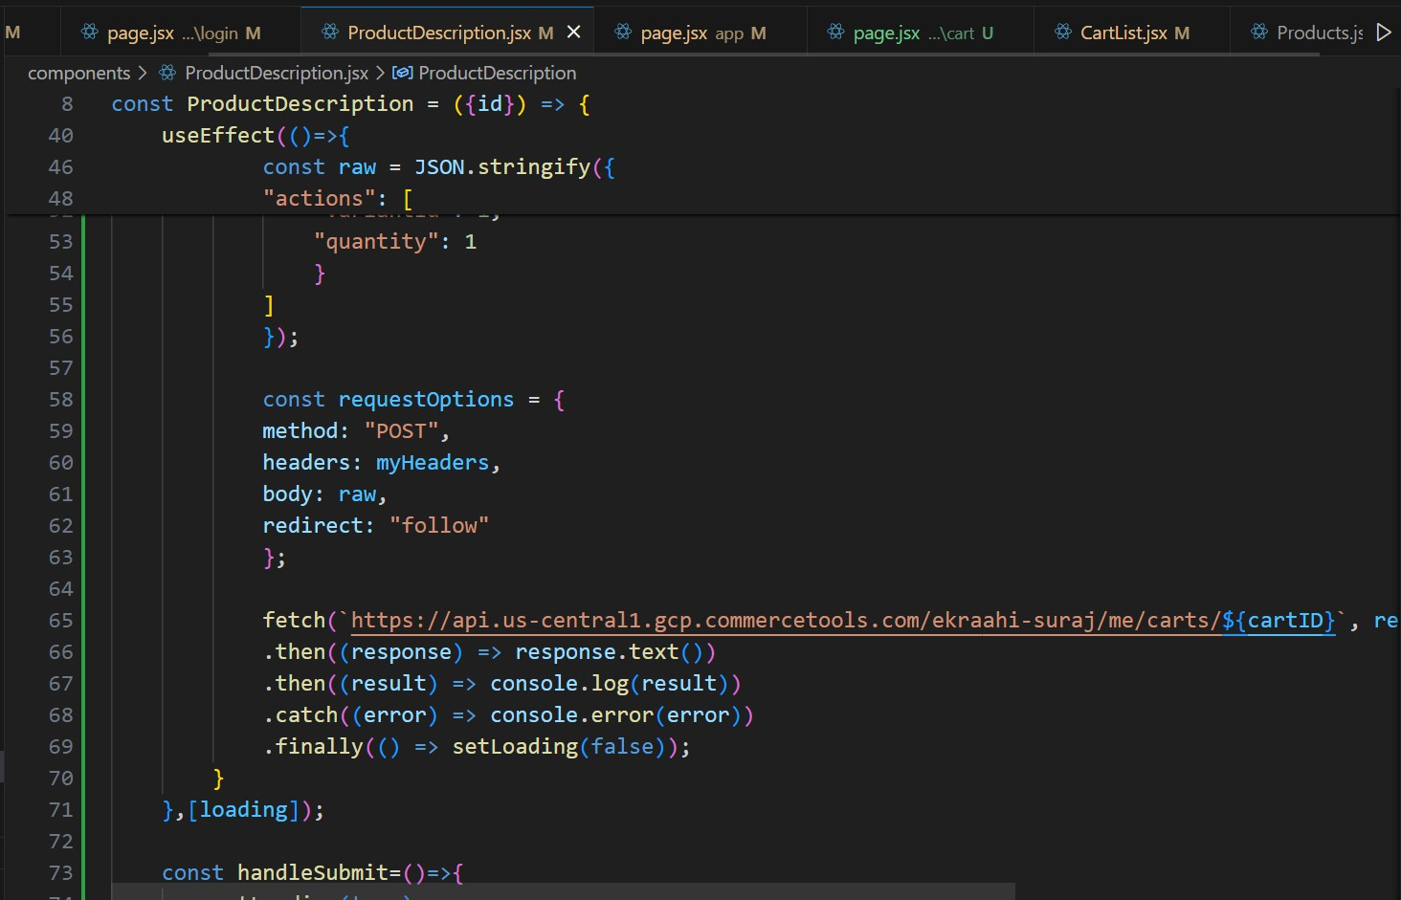

**Fig 3.2.2 : Backend API Connection 2**

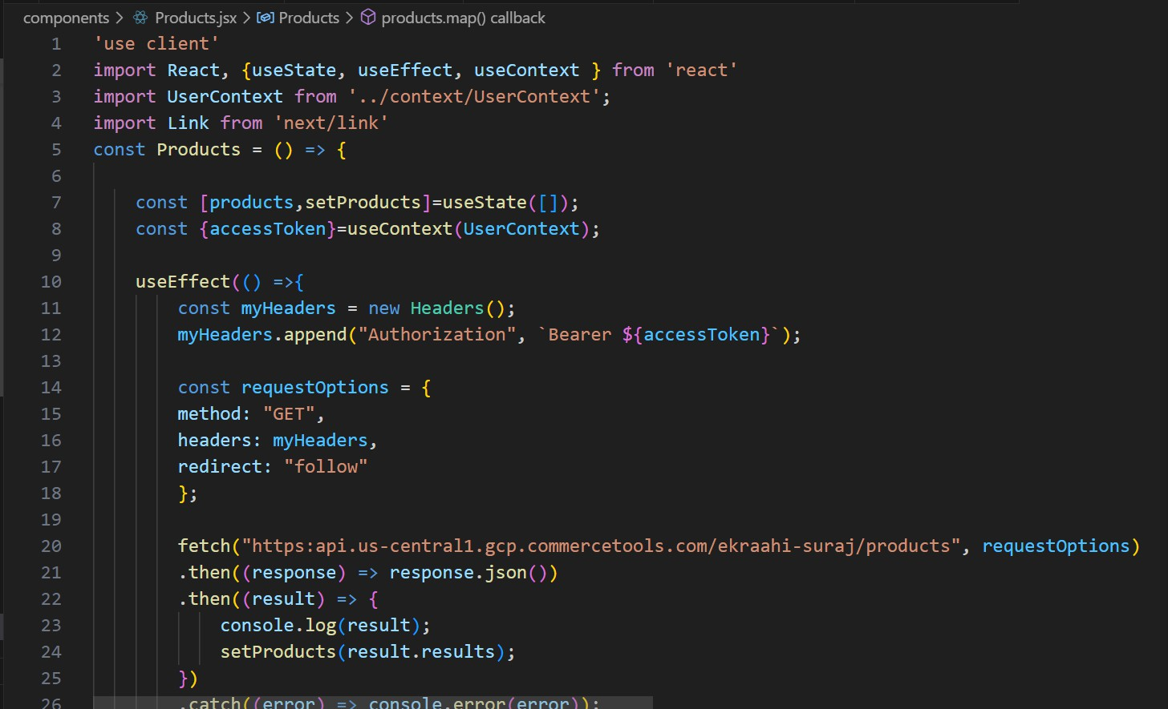

**Fig 3.2.3 : Backend API Connection 3**

### Conclusion

In conclusion, the development of our B2C ecommerce website for men's clothing marks a significant milestone in our journey towards digital commerce excellence. Leveraging the robust capabilities of Commercetools as the backend infrastructure and Next.js as the frontend framework has empowered us to create a seamless, engaging, and responsive online shopping experience.

Throughout the development process, our team demonstrated exceptional skill and dedication, meticulously crafting each aspect of the website to ensure both functionality and aesthetic appeal. The utilization of Next.js not only facilitated efficient rendering and routing but also enabled us to deliver dynamic and interactive user interfaces.

Furthermore, the integration of Commercetools provided us with a scalable and flexible foundation, allowing for the smooth management of product catalogues, inventory, and orders. Leveraging the power of REST APIs, we seamlessly connected the frontend and backend systems, enabling real-time data exchange and enhancing overall performance.

The utilization of Postman as a tool for API testing and debugging proved instrumental in streamlining the integration process, ensuring the reliability and functionality of our solution. This meticulous approach to quality assurance has resulted in a website that not only meets but exceeds the expectations of our users.

In conclusion, our B2C ecommerce website represents the culmination of extensive research, innovation, and collaboration. By harnessing the capabilities of leading-edge technologies and best practices, we have successfully created a platform that not only meets the needs of today's digital consumers but also lays the groundwork for future growth and expansion.

### Future Scope:

Looking ahead, the future scope of our B2C ecommerce project for men's clothing holds immense potential for further enhancement and expansion. Here are some avenues for future development and growth:

1. **Personalization and Customer Engagement:** Implement advanced personalization algorithms to tailor the shopping experience based on user preferences, browsing history, and demographics. Integrate features such as product recommendations, personalized offers, and targeted promotions to enhance customer engagement and drive conversions.
2. **Omni-channel Integration:** Extend the reach of the ecommerce platform by integrating with other sales channels such as mobile apps, social media platforms, and marketplaces. Ensure seamless synchronization of inventory, orders, and customer data across all channels to provide a unified shopping experience.
3. **Internationalization and Localization**: Explore opportunities to expand into international markets by offering support for multiple languages, currencies, and shipping options. Customize the website content and user interface to cater to the preferences and cultural norms of diverse global audiences.
4. **Enhanced Analytics and Insights:** Implement robust analytics tools to gain deeper insights into customer behaviour, sales trends, and website performance. Utilize data-driven insights to optimize product assortment, pricing strategies, and marketing campaigns for better business outcomes.
5. **Integration with Emerging Technologies:** Embrace emerging technologies such as augmented reality (AR) and virtual reality (VR) to enhance the online shopping experience. Allow customers to visualize products in a real-world context, try on virtual outfits, and make more informed purchase decisions.
6. **Enhanced Security and Compliance:** Strengthen security measures to safeguard sensitive customer information and payment data against cyber threats and fraud. Ensure compliance with industry regulations such as GDPR and PCI DSS to build trust and credibility with customers.
7. **Scalability and Performance Optimization:** Continuously optimize the website architecture and infrastructure to handle growing traffic volumes and peak loads during seasonal sales events. Leverage cloud computing services and content delivery networks (CDNs) to improve scalability, reliability, and performance.
8. **Community Building and Social Commerce**: Foster a sense of community and brand loyalty by integrating social features such as user-generated content, product reviews, and social sharing capabilities. Encourage user engagement and advocacy to drive organic growth and word-of-mouth referrals.

By capitalizing on these future opportunities and embracing innovation, our B2C ecommerce project has the potential to evolve into a leading destination for men's fashion, delivering unparalleled value and satisfaction to customers worldwide.

### Bibliography

* + **Commercetools Documentation: -** [**https://docs.commercetools.com/api**](https://docs.commercetools.com/api)
  + **Commercetools Merchant Centre: -**

[**https://mc.us-central1.gcp.commercetools.com/ekraahi-suraj/welcome**](https://mc.us-central1.gcp.commercetools.com/ekraahi-suraj/welcome)

* + **Storefront: -**

[**https://ek-raahi-suraj-frontend.vercel.app/**](https://ek-raahi-suraj-frontend.vercel.app/)

* + **GitHub: -** [**https://github.com/SURAJSCHAUHAN/ek_Raahi**](https://github.com/SURAJSCHAUHAN/ek_Raahi)